**Experiment No: 01**

**Problem Statement:** Write an Assembly code to take two inputs A and B. Then calculate the following, sum1=A+2 and sum2=B-1; where sum1 and sum2 are two variables. Then print the values of sum1 and sum2.

**Objective:** The main purpose of this lab is to show how we take inputs from user and store it in variables with Assembly Code. Then how to add and subtract this number.

**Theory: -** We are getting two user-defined variables (SUM1, SUM2), then we need take two user input and set the input in variables. Store the first variable in SUM1, and also store the second variable in SUM2. Then we addition this number and subtraction this number. show the result in Assembly Code.

**Code:**

. MODEL SMALL

. STACK 100H

.DATA

A DB?

B DB?

MSG DB "Enter the value of A: $"

MSG2 DB "Enter the value of B: $"

MS DB "SUM1=A+2: $"

MS2 DB "SUM2=B-1: $"

. CODE

MAIN PROC

MOV AX, @DATA

MOV DS, AX

MOV BX, @DATA

MOV DS, BX

MOV AH, 9

LEA DX, MSG

INT 21H

MOV AH, 1

INT 21H

MOV BL, AL

MOV A, AL

MOV AH, 2

MOV DL, 0DH

INT 21H

MOV DL, 0AH

INT 21H

MOV AH, 9

LEA DX, MSG2

INT 21H

MOV AH, 1

INT 21H

MOV BL, AL

MOV B, AL

MOV AH, 2

MOV DL, 0DH

INT 21H

MOV DL, 0AH

INT 21H

MOV AH, 9

LEA DX, MS

INT 21H

ADD A, 2

MOV AH, 2

MOV DL, A

INT 21H

MOV AH, 2

MOV DL, 0DH

INT 21H

MOV DL, 0AH

INT 21H

MOV AH, 9

LEA DX, MS2

INT 21H

SUB B, 1

MOV AH, 2

MOV DL, B

INT 21H

MAIN ENDP

END MAIN

**Input and Output:**

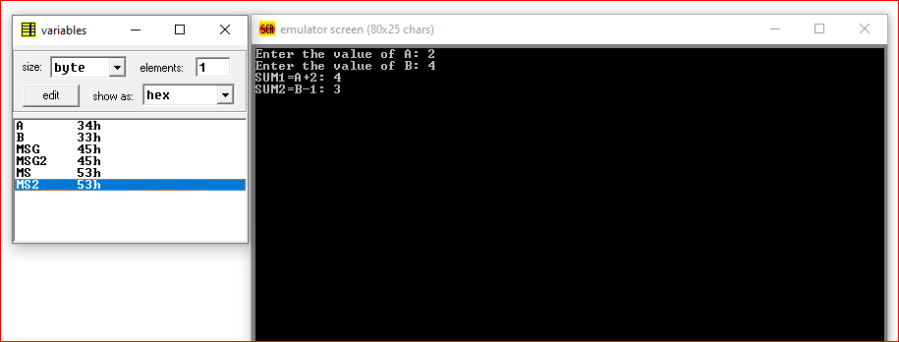

**Conclusion:**

1. We will learn how to take user input in Assembly Code.
2. We also learn that how to store data in Assembly Code.
3. We also learn that how to addition the number in Assembly Code.
4. We also learn that how to subtraction the number in Assembly Code.
5. We learn how to show the result in Assembly Code.